CONTACT: Abby Freeland, sales and marketing director at West Virginia University Press, 304 916 7730, abby.freeland@mail.wvu.edu

Genre-busting novel takes a macabre look at the legacy of the coal industry
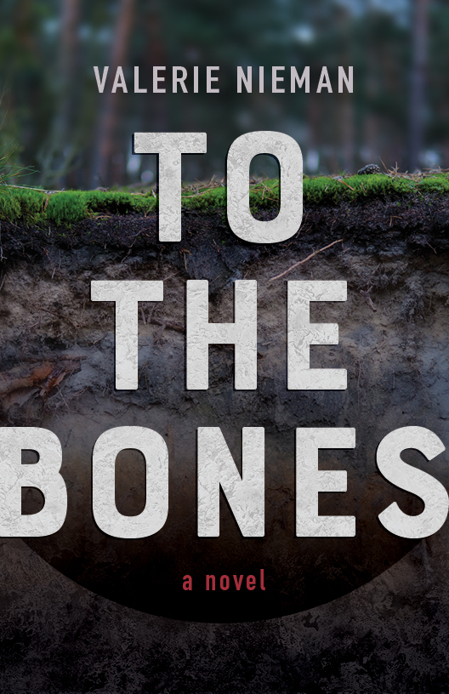
MORGANTOWN, WV—Valerie Nieman, a professor of English at North Carolina A&T State University, has published To the Bones (WVU Press, $19.99), a zombie eco-justice love story mashup that takes a satirical look at the coal industry in West Virginia. Her book tour will take her around Appalachia, including stops in West Virginia, Pennsylvania, Kentucky, Virginia, North Carolina and more.

In To the Bones, Darrick MacBrehon, a government auditor, wakes among the dead. Bloodied and disoriented from a gaping head wound, the man who staggers out of the mine crack in Redbird, West Virginia, is much more powerful—and dangerous—than the one thrown in. An orphan with an unknown past, he must now figure out how to have a future.

Hard-as-nails Lourana Taylor works as a sweepstakes operator and spends her time searching for any clues that might lead to Dreama, her missing daughter. Could this stranger’s tale of a pit of bones be connected? With help from disgraced deputy Marco DeLucca and Zadie Person, a local journalist investigating an acid mine spill, Darrick and Lourana push against everyone who tries to block the truth. Along the way, the bonds of love and friendship are tested, and bodies pile up on both sides.

In a town where the river flows orange and the founding—and controlling—family is rumored to “strip a man to the bones,” the conspiracy that bleeds Redbird runs as deep as the coal veins that feed it.
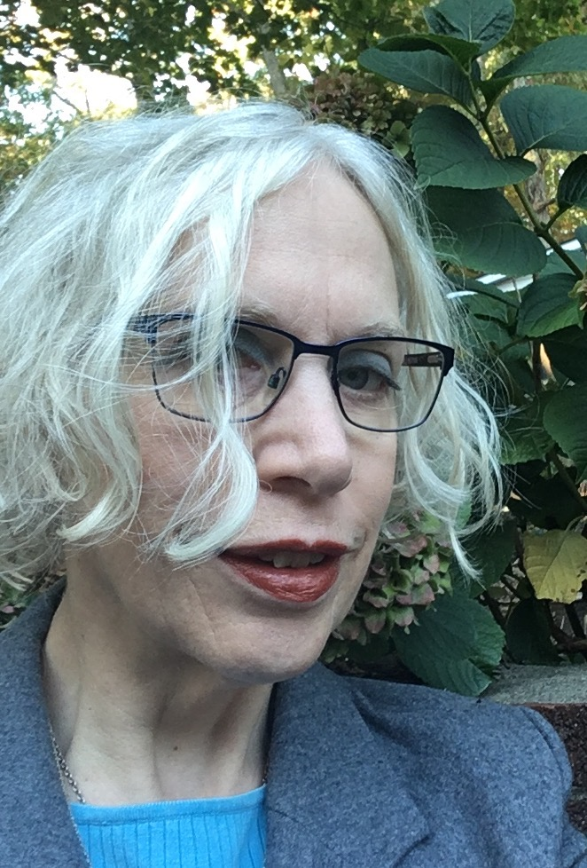
Valerie Nieman is a professor of English at North Carolina A&T State University. A former journalist and farmer in West Virginia, she is the author of three novels, as well as collections of poetry and short fiction. She is a graduate of West Virginia University, and she received an MFA from Queens University of Charlotte.

Listen to Valerie Nieman on The State of Things and read more about To the Bones in Monkeybicycle’s “If My Book” segment.

Praise for To the Bones:

"Evocative, intelligent prose conjures an anxious mood and strong sense of place while spotlighting the societal and environmental devastation wrought by the coal mining industry."
Kirkus Reviews

“An immensely readable story of good versus evil, with enough twists and turns (and twists within turns) to keep you guessing to the last minute.”
Steve Weddle, author of Country Hardball
“This is the West Virginia novel done right: slam-bang storytelling in tightly controlled language, by turns horrific and funny and beautiful.”
Pinckney Benedict, author of Miracle Boy and Other Stories

“A thrilling hike into coal country, Nieman’s page-turner pulls off an audacious trick: empathy for a misunderstood region.”
James Tate Hill, author of Academy Gothic

"A storytelling feat: a pulse-pounding thriller that also manages to construct a whole terrifying, gorgeous mythology."
Clare Beams, author of We Show What We Have Learned

To arrange publicity with Valerie Nieman, contact Abby Freeland, sales and marketing director at West Virginia University Press, abby.freeland@mail.wvu.edu.

Now available!
June 2019 / 204pp / PB 978-1-946684-98-1: $19.99 / eBook 978-1-946684-99-8: $19.99

